
Final Project Report

1. Introduction
1.1. Project overviews
This project focuses on agricultural crop production trends from 1997 to 2021 across India, states-wise production distribution with maps, season-wise agricultural production share, identification
of states with high and low production, identification of high performing crops and an in1.2. Objectives: -
teractive
a hboard for ll visualizations.
d•sTo understand India’s agricultural crop production.To identify regions with low and high crop yields.To understand long term production trends.To evaluate the impact of seasonal variations
2. Project Initialization and Planning Phase 2.1. Define Problem Statement

Problem Statement

I am I’m trying to But Because Which makes me feel

(PS)

PS-1 Government Policy Analyst

PS-2 Small-Scale
Farmer

Improve agricultural productivity across India.

Maximize crop yield
and income

It is difficult to understand hidden patterns of crops across India.

It is difficult to find out which crop has high yield and high demand during a season

There is no single visual platform that shows productivity pattern of crops.

There is no single visual platform that shows crop yield and demand during seasons.

Challenging to make effective policies for farmers to increase productivity.

Challenging to make a decision which crop I should grow to maximize yield and Income.

2.2. Project Proposal (Proposed Solution)

Project Overview

Objective ❖ To understand India’s agricultural crop production.
• To identify regions with low and high crop yields.
• To understand long term production trends.
• To evaluate the impact of seasonal variations.

Scope Analysis of crop production from 1997 to 2021.
Problem Statement

Description There is no single visual to show seasonal and yearly trends in
crop production, cultivated area for different crops, regions with high and
low production, comparison of cultivated areas among different
crops.
Impact This visualization will help policymakers to develop effective

policies

Proposed Solution
to increase agricultural productivity, allocate resources effectively
and help farmers to make informed about crop selection based on
regional productivity, high performing crops to make better farming
decisions and reduce risk.

Approach Collect the data from 1997 to 2021 on crop production across India from the ministry of agriculture and other agriculture
related
websites.
Key Features Agriculture production trends from 1997 to 2021 across India,
states- wise production distribution with maps, season-wise agricultural production share, identification of states with high and low
production, identification of high performing crops and an interactive
dashboard for all visualizations.

Resource Requirements

Resource Type Description Specification/Allocation
of cores
logs

Hardware

CPU/GPU specifications, number 2 x NVIDIA V100 GPUs
Computing Resources

Memory RAM specifications 8 GB

Disk space for data, models, and 512GB SSD
Storage

Software

Frameworks Python frameworks Flask

Libraries Additional libraries scikit-learn, pandas, numpy
web

Data Collection Plan

Raw Data Sources

Identified
Dataset is collected from agriculture department of India,

Smart

bridge site, UPAg Portal and Directorate of Economics and

Statistics.

Ministry of Agriculture and Farmers
Welfare
Directorate of Economics and
Statistics
Smart bridge site

UPAg Portal

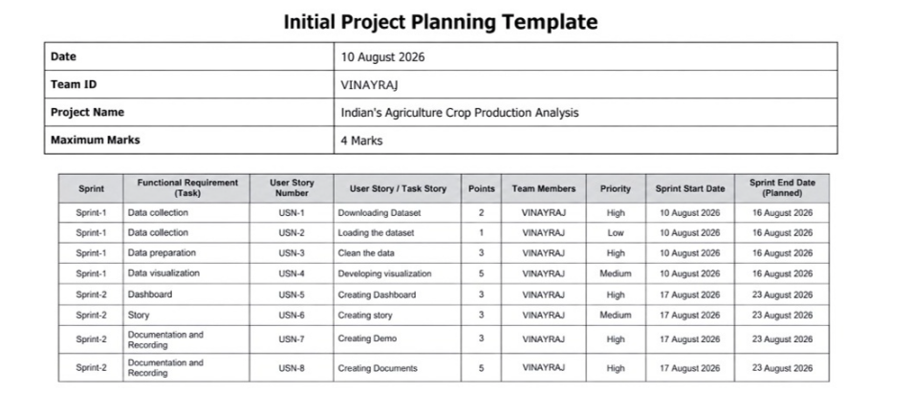
Raw Data Sources
rtEst

Source

Name

Dataset 1

Dataset 2

Dataset 3

Description

Ministry of

Agriculture and

Farmers Welfare Directorate of

Economics and

Statistics
Smart bridge site

Location/URL Format Size

https://agriwelfare
.gov.in/en/StatHo CSV 1GB

https://data.desagr

i.gov.in/website/c Excel 1GB rops-apy-report-

https://thesmartbri Excel 1 GB
dge.com/
Access

Permissions

Public

Public

Public
3.2. Data Quality Report

Data

Source

Dataset 1

Data Quality Issue

Some missing numbers.

Severity

Moderate

Resolution Plan

Filter the data and add missing

numbers

Dataset 2

Dataset 3
Reports related to agriculture

production for each crop are

separated.

Some values of dataset are

different from other dataset

High Make a single excel file containing all reports.

Compare with other dataset and medium find authentic data from official
websites.

3.3. Data Exploration and Preprocessing

Section Description

Data Overview
Dataset is related to India’s agriculture crop production from
1997 to 2021.

Execute data cleaning workflows to impute missing entries, deduplicate records, and rectify data anomalies
Data Cleaning

Data manipulation: filtering, sorting, pivoting, and creating calculated columns.
Data Transformation

Data Type Conversion Rectifying Datatype

Split or merge columns as needed.
Column Splitting and
Merging

Data Modeling Define relationships between tables and construct measures.
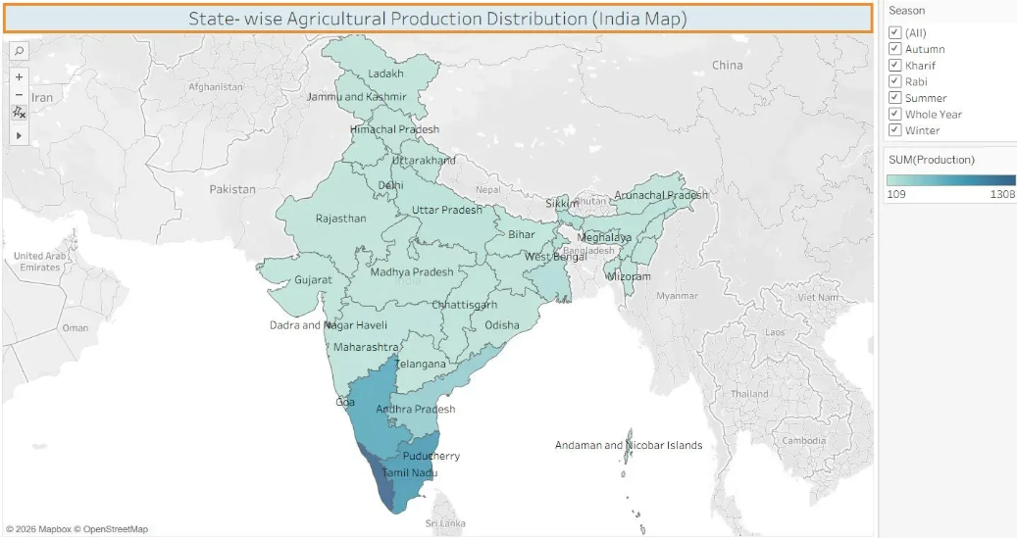
3. State- wise Agricultural Production Distribution

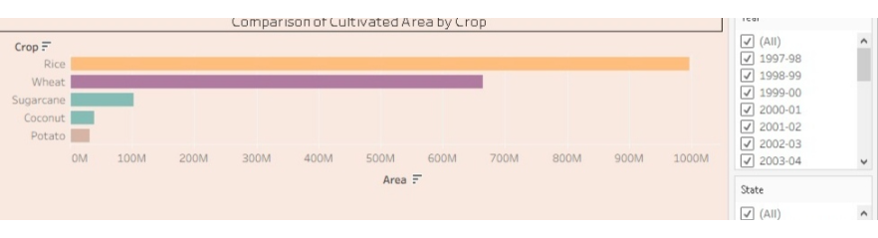
4. Comparison of Cultivated Area by crop

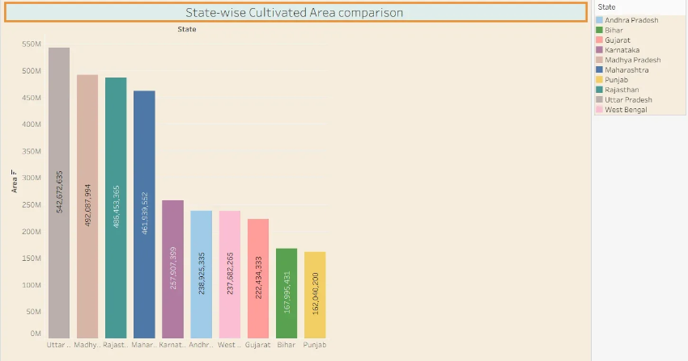
5. State-wise cultivated Area comparison
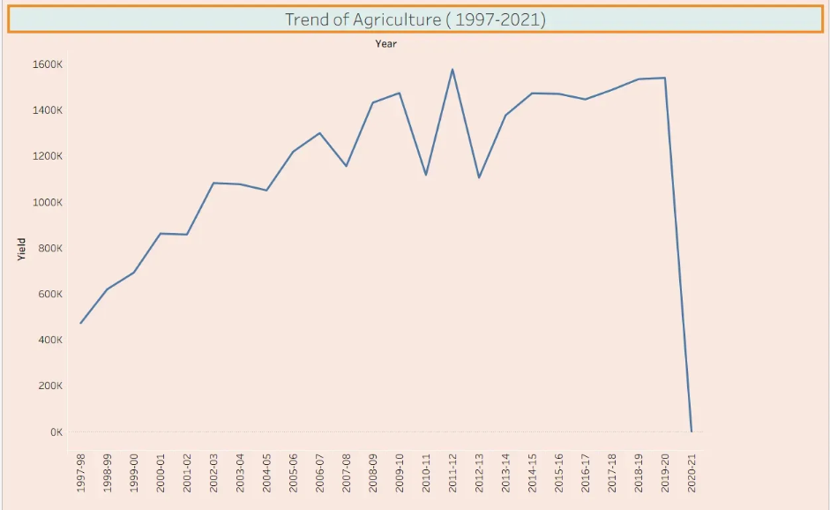
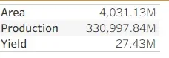
Save Processed Data Save the cleaned and processed data for future use.

4. Data Visualization
4.1. Framing Business Questions

Q1. What is the trend of Agriculture Yield from 1997 to 2021?
Ans. In following visualization, line chart shows the trend of agriculture yield from 1997 to 2021.

Q2. What is total area and production of India’s Agriculture? Ans.
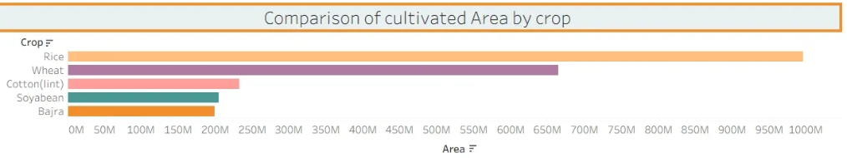
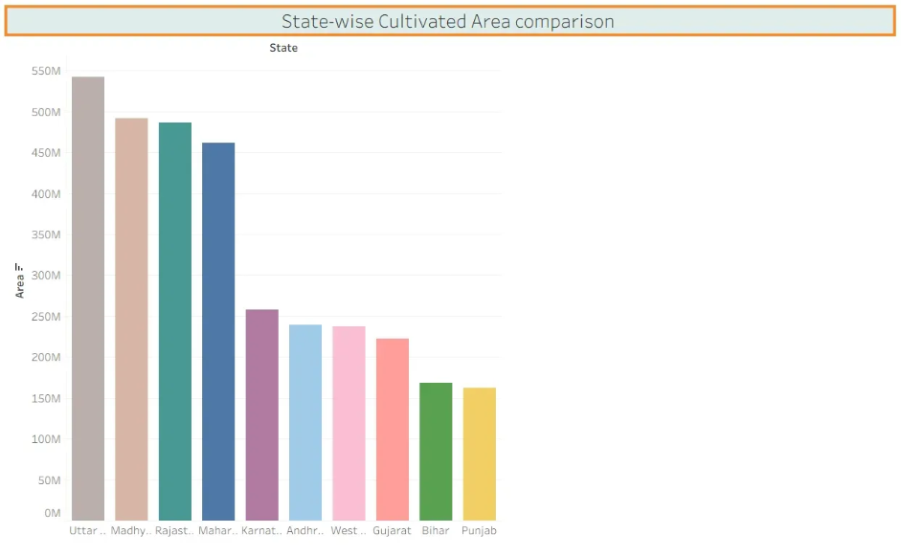
Q3. Which crops have the highest cultivated area?
Ans. Rice has the highest cultivated area, followed by Wheat, cotton, soyabean and Bajra.

Q4. Which states have the highest cultivated area?

Ans. Uttar Pradesh has the highest cultivated area followed by Madhy Pradesh, Rajasthan, Maharashtra Karnatak and Andrapradesh.

Q5. Which states have the highest agricultural production?
Ans. Kerala has the highest agricultural production followed by Tamil Nadu, Karnataka, Andhra Pradesh and West Bengal.
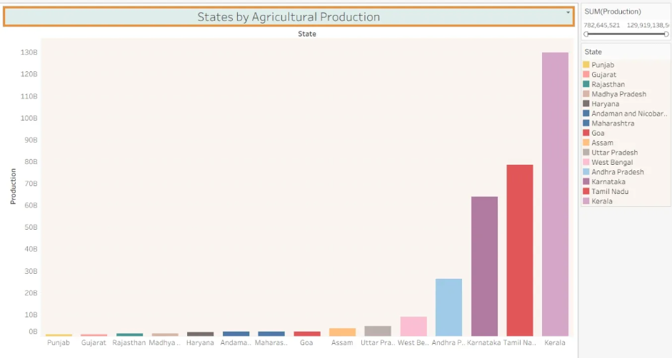
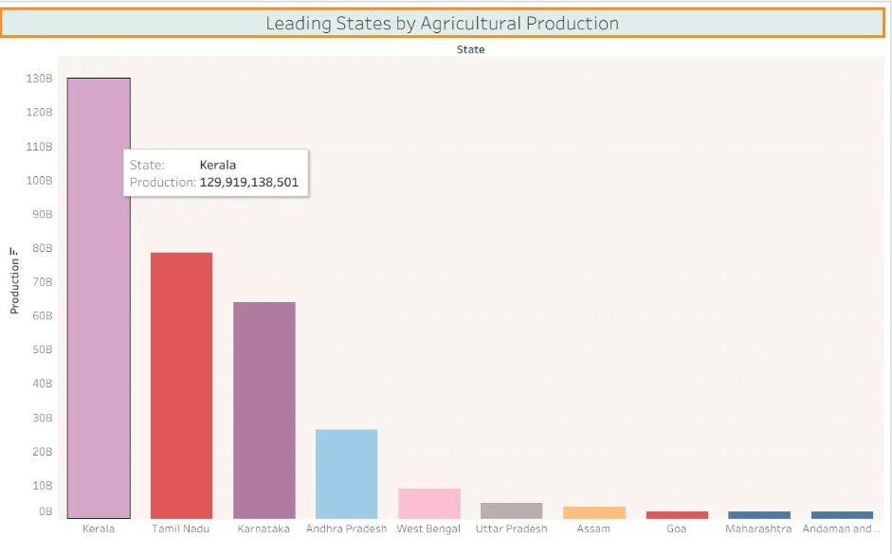

Q6. Which states have low agricultural production? Ans. These states have low agricultural production:-
Punjab, Gujarat, Rajasthan, Madhya Pradesh

Q7. What is year wise Total Agricultural production from 1997 to 2021?
Ans. Following bar graph shows year wise total agricultural production from 1997 to 2021: -
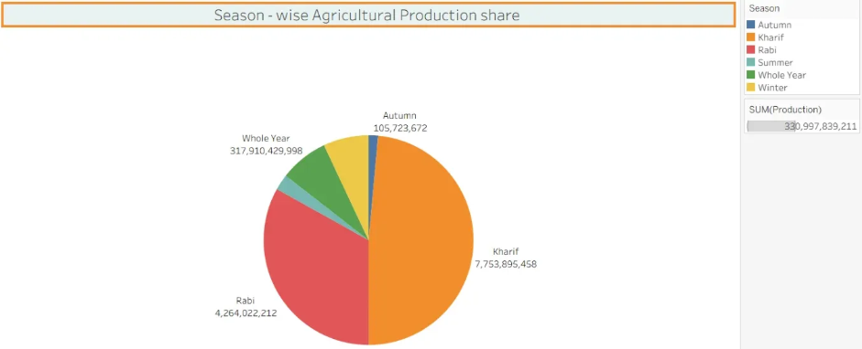
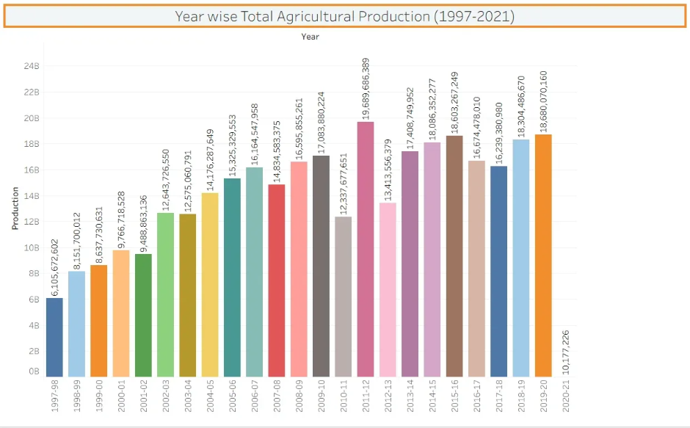

Q8. What is the season – wise Agricultural Production share?
Ans. Following pie chart shows season-wise Agricultural production share: -

Q9. What is the production of Potato during the season of kharif and rabi ?
Ans. The production of potato during the season of kharif and rabi is 204,606,567 tonnes. Following ma shows the states which produce potato during these seasons: -

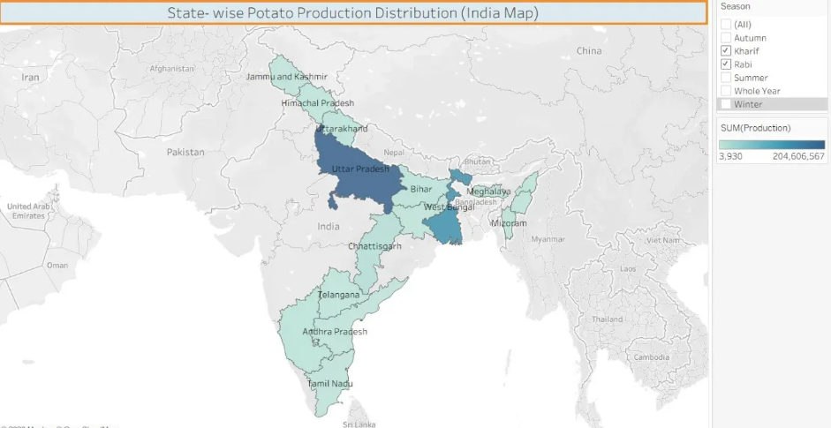
4.2. Developing Visualizations 1. Performance Summary

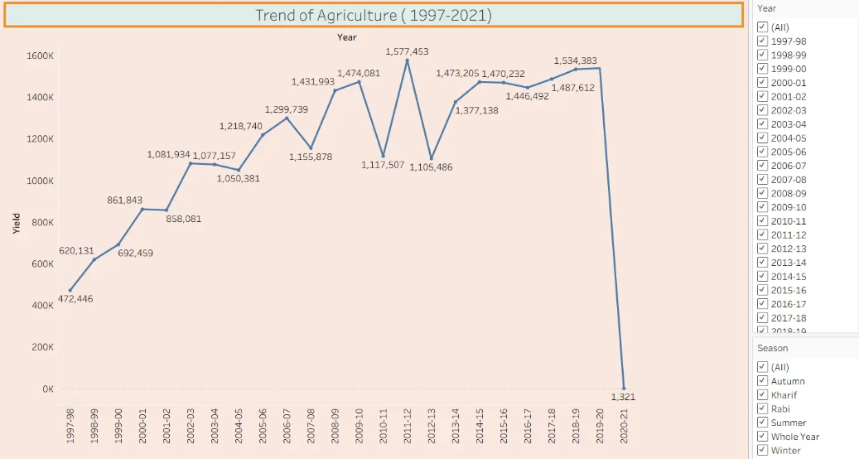
2. Trend of Agriculture from 1997 to 2021

3. State- wise Agricultural Production Distribution


4. Comparison of Cultivated Area by crop


5. State-wise cultivated Area comparison
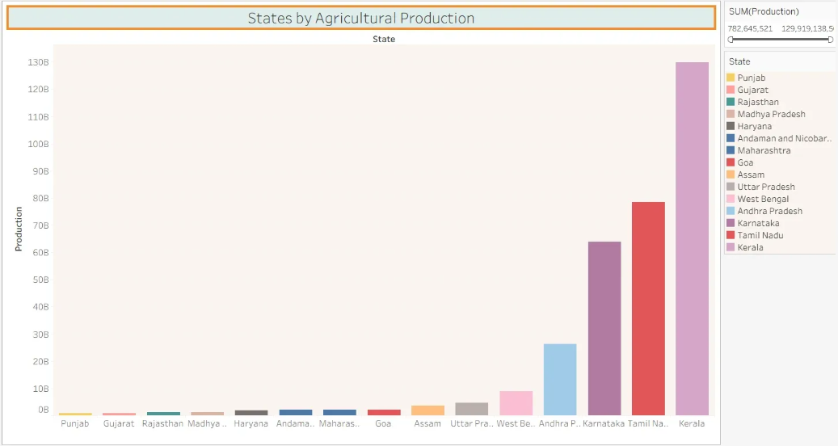
6. States by Agricultural Production

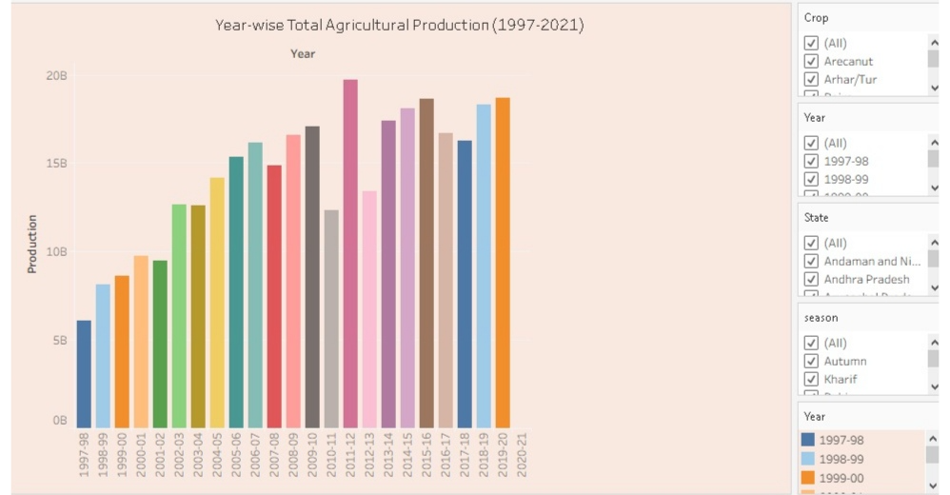
7. Year wise total Agricultural Production
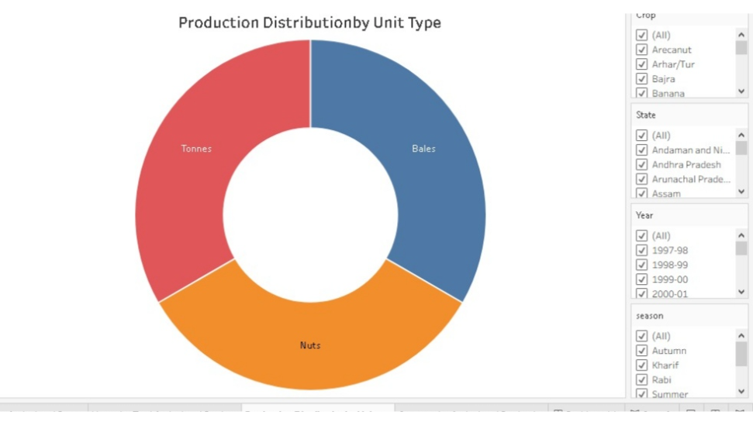
8. Production Distribution by Unit Type

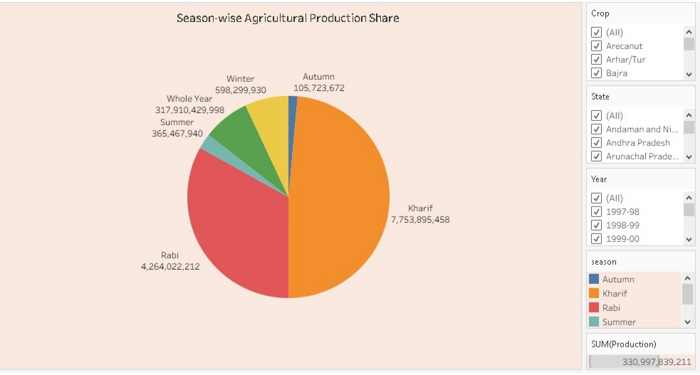
9. Season- wise agricultural production share
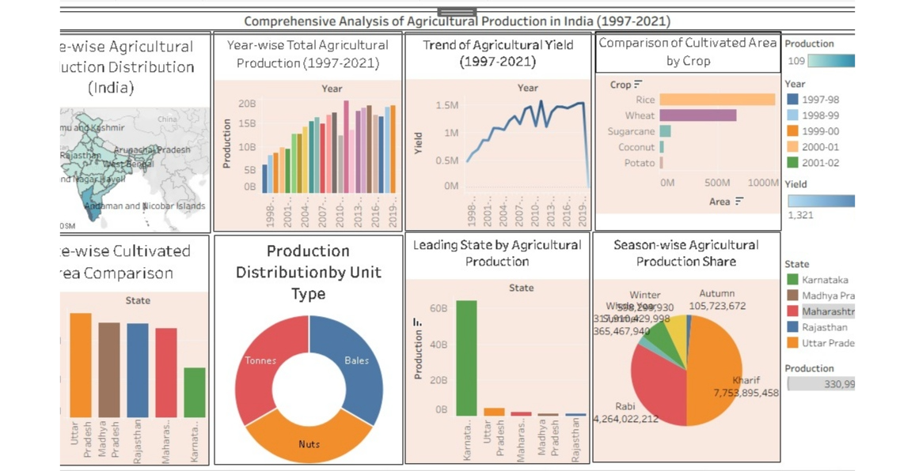

5. Dashboard
5.1. Dashboard Design File
Activity 1: Interactive and visually appealing dashboards

Here are potential outcomes from the dashboard image provided: -

• India’s Agriculture performance summary: -Total area =4031.13Million HectareTotal production=330,997.84 Million tonnesTotal yield= 27.43 million tonnesLeading states by Agricultural production: -KeralaTamil Nadu KarnatakaStates with low production: -PunjabGujrat Rajasthan

• Cultivated area by crops: -
Rice has highest cultivated area followed by wheat, cotton, soyabean and bajra
• Trend of agriculture from 1997 to 2021
○ As shown in line graph India’s agriculture yield increase from 1997 to 2019 but suddenly goes
• down in 2020Season- wise agriculture production share
Kharif has highest share followed by Rabi i.e. Kharif and Rabi are the season in which production is highest in a year.

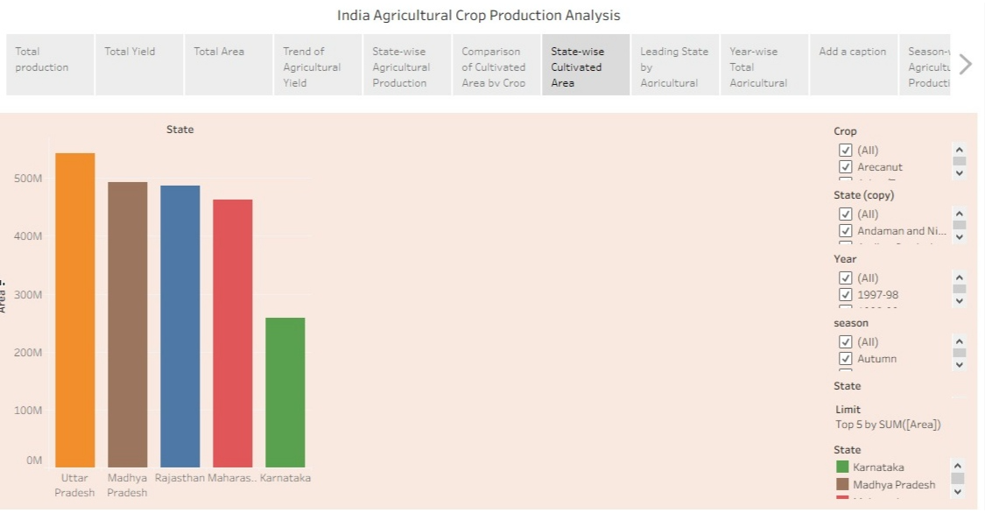
Activity 2

Publish Dashboard on Tableau Public and Paste the Dashboard Public link below:

https://public.tableau.com/views/Vinayraj/Dashboard1?:language=en-US&publish=yes&:sid=& direct=auth&:display_count=n&:origin=viz_share_link

6. Report
6.1. Story Design File

Observations:

• Yearly trend of agriculture production from 1997 to 2021.
• Leading states by production
• States with low production
• Seasonal production variations
• Comparison of States by cultivated area
• Total area of production and yield

Activity 2:

Publish Story on Tableau Public and Paste Public link below

https://public.tableau.com/views/Vinayraj/Story2?:language=en-US&publish=yes&:sid=&:redirect=auth&:display_count origin=viz_share_link

7. Performance Testing
7.1 Utilization of Data filters
Data filters are used in visualizations to see the required visualization. 7.2 No of Visualization - 9

8. Conclusion/Observation
In conclusion, India’s agricultural crop production is an important part of the country’s economy and plays a major role in providing food and employment to a large population. The analysis shows that Ind produces a wide range of crops, such as rice, wheat, pulses, sugarcane, cotton, oilseeds, and various horticultural crops. States that have high cultivated area but don’t produce crops accordingly. Wheat an Rice are two major crops in India.
9. Future Scope
The future of crop production in India has significant potential for growth through the adoption of modern technology, sustainable farming practices, and better agricultural planning. Crop production analysis can play an important role in identifying production trends, improving resource utilization, an supporting farmers and policymakers in making better decisions.

10. Appendix
10.1 GitHub & Project Demo Link GitHub Link
https://github.com/vinayrajkhedi1221/India-s-Agricultural-Crop-Production-Analysis

Project Demo Link
https://drive.google.com/file/d/13rMuya8E5OOfknCtypFX_qcR-km6nx-4/view?usp=drivesdk

